BANK LOAN REPORT QUERY DOCUMENT
- BANK LOAN REPORT | SUMMARY
KPI’s:
Total Loan Applications
select count(id)as Total_Loan_Applications from Bank_loan
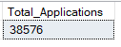
MTD Loan Applications
SELECT
COUNT(id) AS MTD_Total_Loan_Applications
FROM
Bank_loan
WHERE
EXTRACT(MONTH FROM ISSUE_DATE) = 12
AND EXTRACT(YEAR FROM ISSUE_DATE) = 2021;
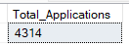
PMTD Loan Applications
SELECT
COUNT(id) AS PMTD_Total_Loan_Applications
FROM
Bank_loan
WHERE
EXTRACT(MONTH FROM ISSUE_DATE) = 11
AND EXTRACT(YEAR FROM ISSUE_DATE) = 2021;
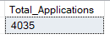

Total Funded Amount
SELECT SUM(loan_amount) AS Total_Funded_Amount FROM bank_loan
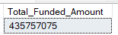
MTD Total Funded Amount
select sum(loan_amount) as MTD_Total_Funded_Amount from Bank_loan
WHERE
EXTRACT(MONTH FROM ISSUE_DATE) = 12
AND EXTRACT(YEAR FROM ISSUE_DATE) = 2021;
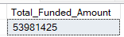
PMTD Total Funded Amount
select sum(loan_amount) as PMTD_Total_Funded_Amount from Bank_loan
WHERE
EXTRACT(MONTH FROM ISSUE_DATE) = 11
AND EXTRACT(YEAR FROM ISSUE_DATE) = 2021;
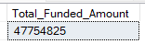

Total Amount Received
SELECT SUM(total_payment) AS Total_Amount_Collected FROM bank_loan
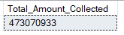
MTD Total Amount Received
select sum(total_payment) as MTD_Total_Amount_Recived from Bank_loan
WHERE
EXTRACT(MONTH FROM ISSUE_DATE) = 12
AND EXTRACT(YEAR FROM ISSUE_DATE) = 2021;
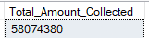
PMTD Total Amount Received
select sum(total_payment) as PMTD_Total_Amount_Recived from Bank_loan
WHERE
EXTRACT(MONTH FROM ISSUE_DATE) = 11
AND EXTRACT(YEAR FROM ISSUE_DATE) = 2021;
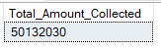

Average Interest Rate
SELECT AVG(int_rate)*100 AS Avg_Int_Rate FROM bank_loan
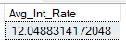
MTD Average Interest
select round(avg(int_rate), 4) *100 as MTD_Avg_Interest_Rate from Bank_loan
WHERE
EXTRACT(MONTH FROM ISSUE_DATE) = 12
AND EXTRACT(YEAR FROM ISSUE_DATE) = 2021;
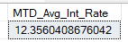
PMTD Average Interest
select round(avg(int_rate), 4) *100 as PMTD_Avg_Interest_Rate from Bank_loan
WHERE
EXTRACT(MONTH FROM ISSUE_DATE) = 11
AND EXTRACT(YEAR FROM ISSUE_DATE) = 2021;
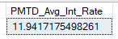

Avg DTI
SELECT AVG(dti)*100 AS Avg_DTI FROM bank_loan
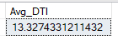
MTD Avg DTI
select round(avg(dti), 4) * 100 as MTD_Avg_DTI from Bank_loan
WHERE
EXTRACT(MONTH FROM ISSUE_DATE) = 12
AND EXTRACT(YEAR FROM ISSUE_DATE) = 2021;
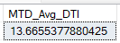
PMTD Avg DTI
select round(avg(dti), 4) * 100 as PMTD_Avg_DTI from Bank_loan
WHERE
EXTRACT(MONTH FROM ISSUE_DATE) = 11
AND EXTRACT(YEAR FROM ISSUE_DATE) = 2021;
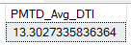

GOOD LOAN ISSUED
Good Loan Percentage
SELECT
FLOOR(
(COUNT(CASE WHEN loan_status IN ('Fully Paid', 'Current') THEN 1 END)
/ COUNT(id)) * 100
) AS Good_Loan_Percentage
FROM
Bank_loan;
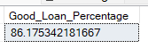
Good Loan Applications
select count(id) as Good_Loan_Applications from Bank_loan
where Loan_Status = 'Fully Paid' or Loan_Status = 'Current'
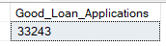
Good Loan Funded Amount
select sum(Loan_amount) as Good_Loan_Funded_Amount from Bank_loan
where Loan_Status = 'Fully Paid' or Loan_Status = 'Current'
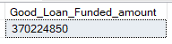

Good Loan Amount Received
select sum(Total_payment) as Good_Loan_Recived_Amount from Bank_loan
where Loan_Status = 'Fully Paid' or Loan_Status = 'Current'
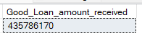

BAD LOAN ISSUED
Bad Loan Percentage
SELECT
FLOOR(
(COUNT(CASE WHEN loan_status IN ('Charged Off') THEN 1 END)
/ COUNT(id)) * 100
) AS Bad_Loan_Percentage
FROM
Bank_loan;
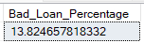
Bad Loan Applications
select count(id) as Bad_Loan_Applications from Bank_loan
where Loan_Status = 'Charged Off'
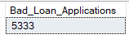
Bad Loan Funded Amount
select sum(Loan_amount) as Bad_Loan_Funded_Amount from Bank_loan
where Loan_Status = 'Charged Off'
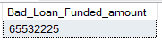
Bad Loan Amount Received
select sum(Total_payment) as Bad_Loan_Recived_Amount from Bank_loan
where Loan_Status = 'Charged Off'
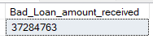

LOAN STATUS
SELECT
loan_status,
COUNT(id) AS Total_Loan_applications,
SUM(total_payment) AS Total_Amount_Received,
SUM(loan_amount) AS Total_Funded_Amount,
AVG(int_rate * 100) AS Interest_Rate,
AVG(dti * 100) AS DTI
FROM
Bank_loan
GROUP BY
loan_status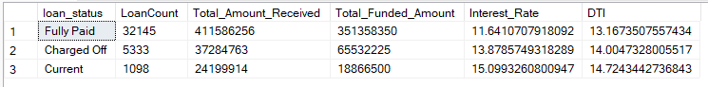

SELECT
loan_status,
SUM(total_payment) AS MTD_Total_Amount_Received,
SUM(loan_amount) AS MTD_Total_Funded_Amount
FROM
Bank_loan
WHERE
EXTRACT(MONTH FROM issue_date) = 12
GROUP BY
loan_status;
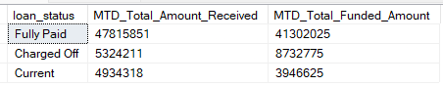

- BANK LOAN REPORT | OVERVIEW
MONTH
SELECT
EXTRACT(MONTH FROM issue_date) AS Month_Number,
TO_CHAR(issue_date, 'Month') AS Month_Name,
COUNT(id) AS Total_Loan_Applications,
SUM(loan_amount) AS Total_Funded_Amount,
SUM(total_payment) AS Total_Amount_Received
FROM
Bank_loan
GROUP BY
EXTRACT(MONTH FROM issue_date),
TO_CHAR(issue_date, 'Month')
ORDER BY
EXTRACT(MONTH FROM issue_date);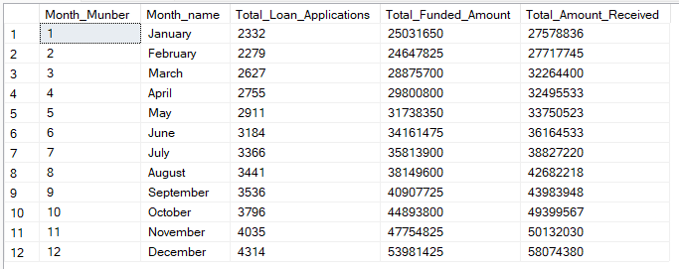

STATE
SELECT
address_state AS State,
COUNT(id) AS Total_Loan_Applications,
SUM(loan_amount) AS Total_Funded_Amount,
SUM(total_payment) AS Total_Amount_Received
FROM Bank_loan
GROUP BY address_state
ORDER BY address_state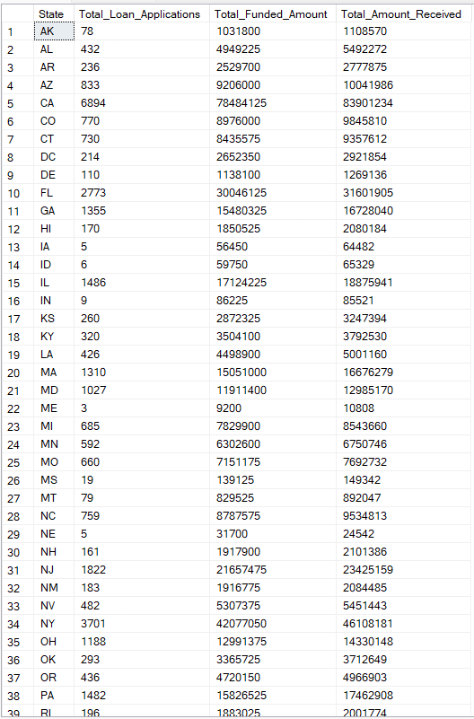

TERM
SELECT
term AS Term,
COUNT(id) AS Total_Loan_Applications,
SUM(loan_amount) AS Total_Funded_Amount,
SUM(total_payment) AS Total_Amount_Received
FROM Bank_loan
GROUP BY term
ORDER BY term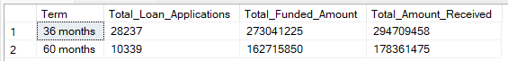

EMPLOYEE LENGTH
SELECT
emp_length AS Employee_Length,
COUNT(id) AS Total_Loan_Applications,
SUM(loan_amount) AS Total_Funded_Amount,
SUM(total_payment) AS Total_Amount_Received
FROM bank_loan
GROUP BY emp_length
ORDER BY emp_length
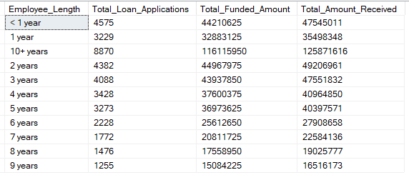
PURPOSE
SELECT
purpose AS PURPOSE,
COUNT(id) AS Total_Loan_Applications,
SUM(loan_amount) AS Total_Funded_Amount,
SUM(total_payment) AS Total_Amount_Received
FROM bank_loan
GROUP BY purpose
ORDER BY purpose
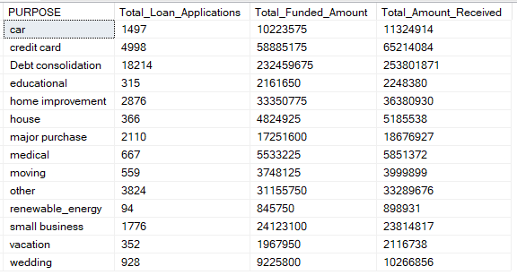

HOME OWNERSHIP
SELECT
home_ownership AS Home_Ownership,
COUNT(id) AS Total_Loan_Applications,
SUM(loan_amount) AS Total_Funded_Amount,
SUM(total_payment) AS Total_Amount_Received
FROM bank_loan
GROUP BY home_ownership
ORDER BY home_ownership
